PERSONAL PROPERTY POLICY

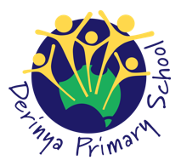

DERINYA PRIMARY SCHOOL

Purpose
To explain Derinya Primary School’s policy in relation to personal property and to ensure that special or valuable items of personal property are not brought to school.

Scope
This policy applies to all school activities, including camps and excursions.

Policy
Derinya Primary School understands that staff and/or students may sometimes like to bring items of personal property to school.
The Department of Education and Training does not have insurance for personal property of staff, students and visitors. Derinya does not take responsibility for items of personal property that are lost, stolen or damaged at school or during school activities. Damage to personal property brought to school is the responsibility of the owner of that property.
Derinya encourages staff and students not to bring items of value to school, or to obtain appropriate insurance for such items.
If students bring items of value to school, they will be confiscated and stored securely in their teacher’s office until the end of the day, when the items may be collected by the student and/or parent.

Review Cycle
This policy was last updated in November 2019 and is scheduled for review in November 2023.

